User Manual

Here we get to explain how the page can be used for a new user. On the home page it is shown how the menu will be placed changing the dishes to be able to order.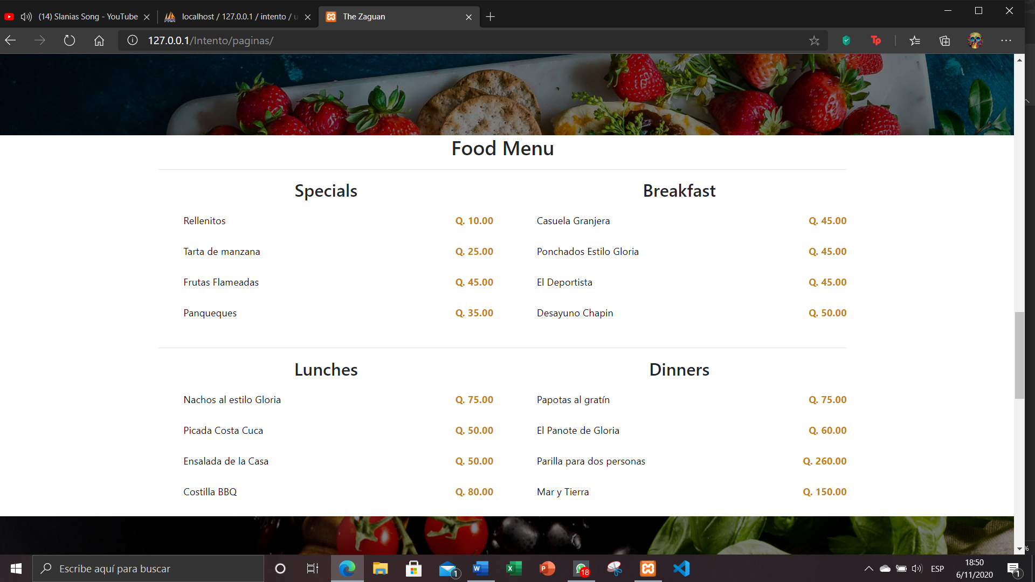

On the menu page you will find each of the dishes, with the name and price, a button that when clicked will send them to another page with the more specific details of the specific dish. There are also other buttons to redirect you to the pages only with the dishes you want to see.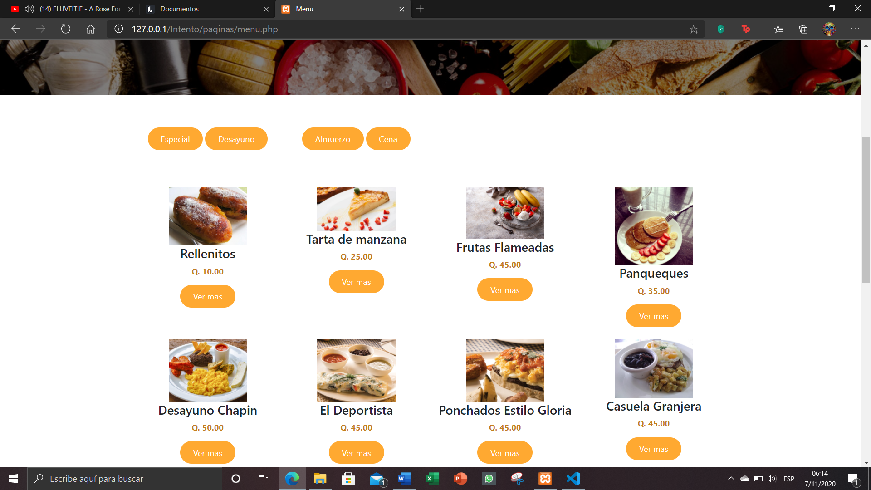

Here you can see only the dishes that will correspond to each of the menus that we will sell in our restaurant. And you can also click to go to the other menus and to see the details of the dishes that we select.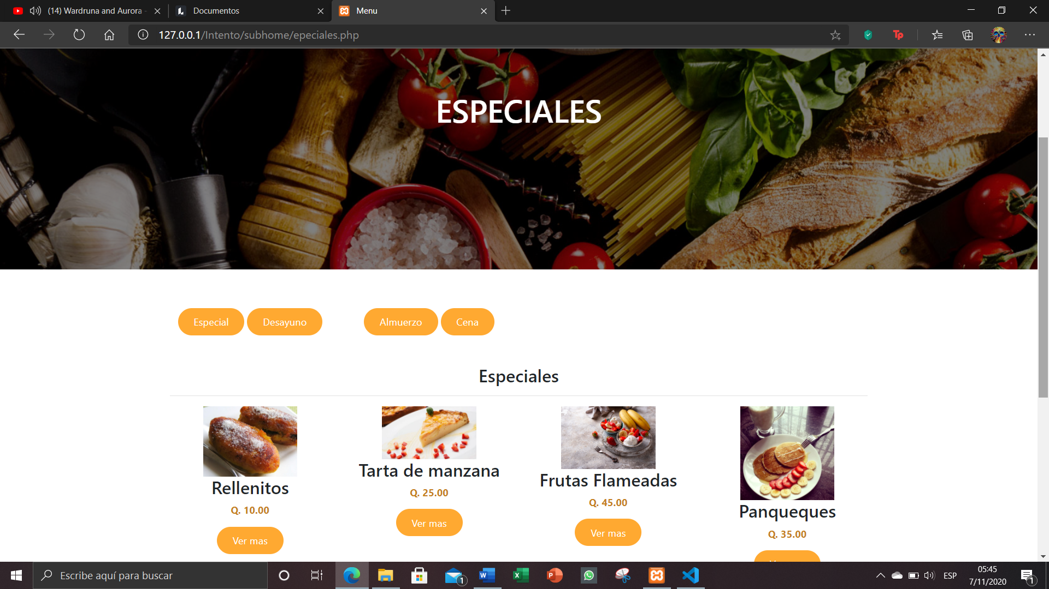 Here is shown all the details of each of the dishes that we want to observe and know that this fact, there is a button to click to redirect to the purchase page.

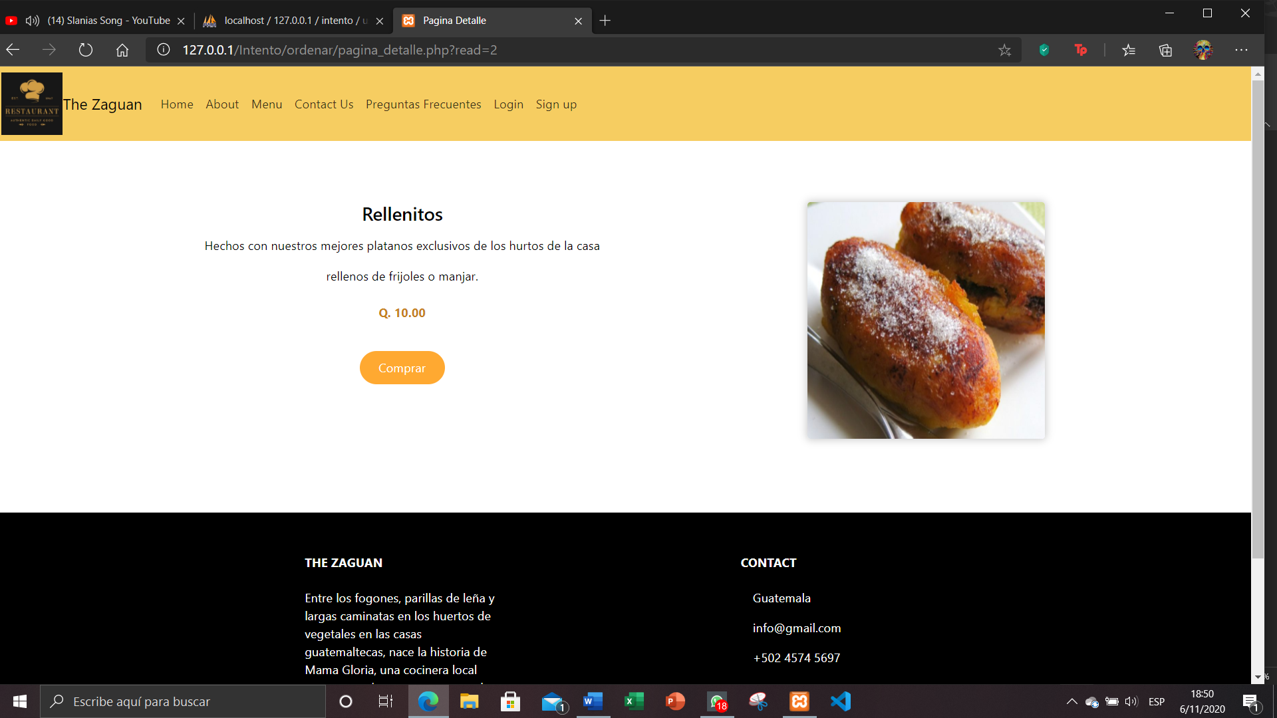

As shown here, when one wants to buy a dish, they give them the add to cart button to add them to the purchase detail. You can also search for a dish using search.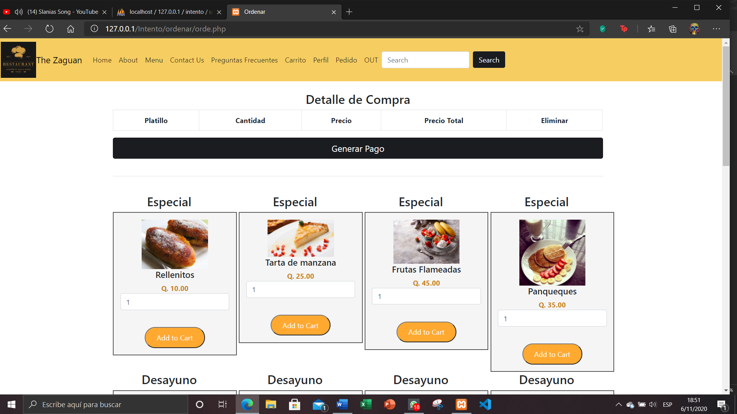

When doing the search by name or by detail, you can go to a page to add to the cart and the amount you want to add from the dish.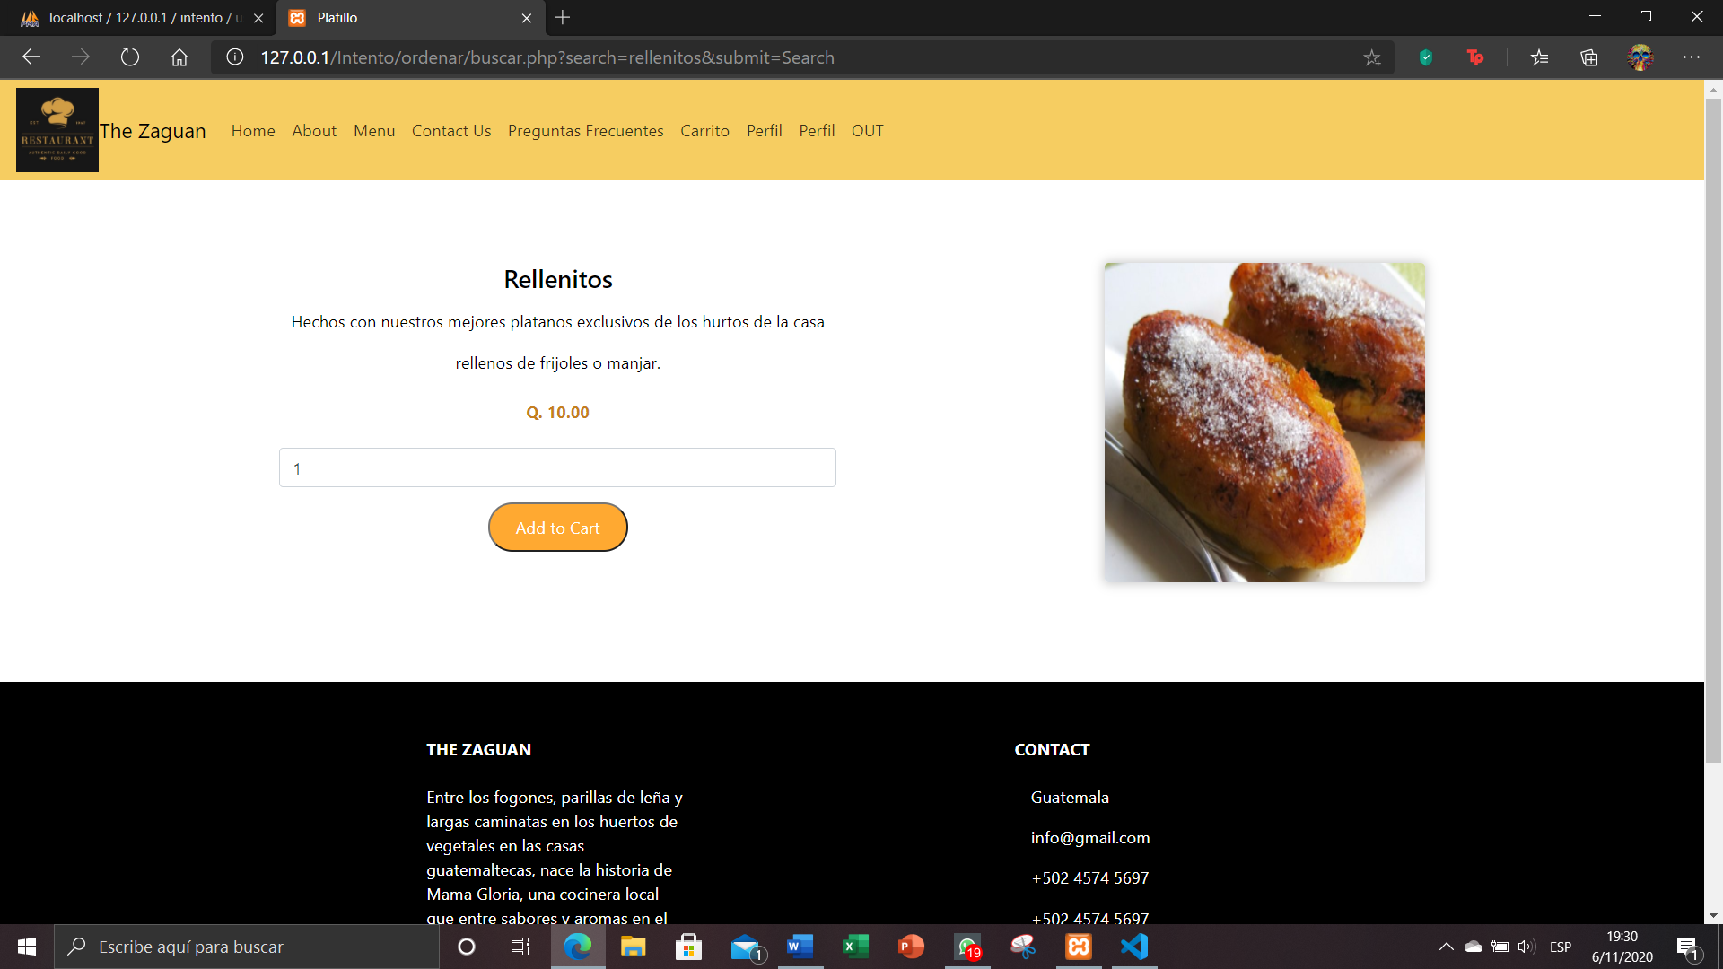

Here you can see that the dish that you enter when you click on the button is automatically added in the detail of how many quantities you want to add, and can be deleted if one gets confused.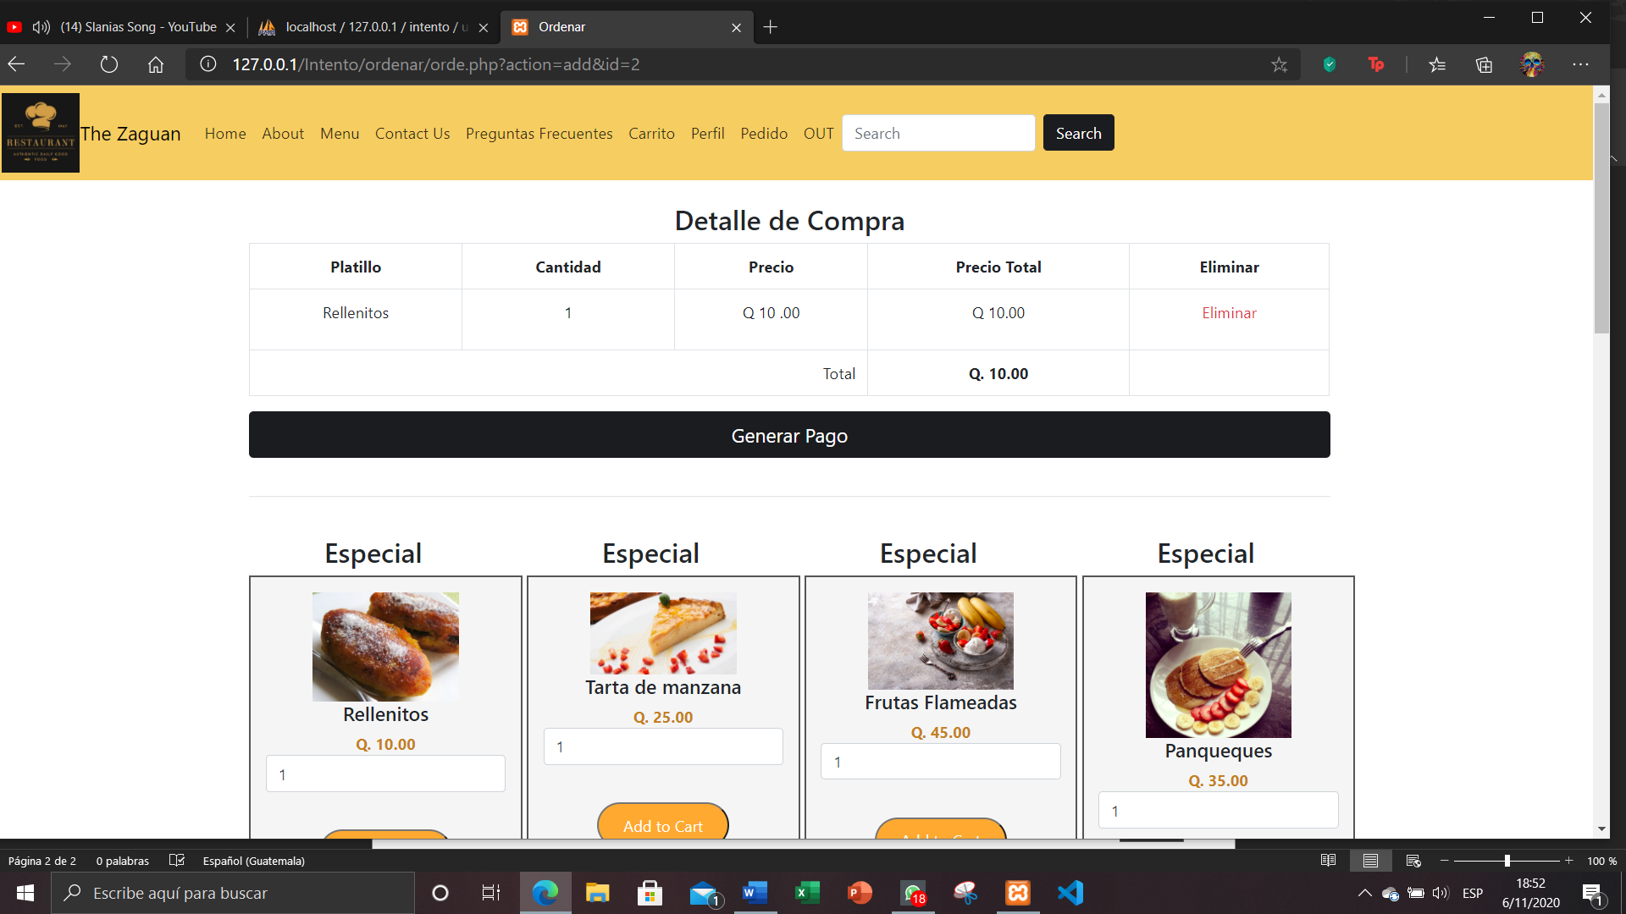

It is given in the button to generate order, if you are a user who is logged in, you can place the order, otherwise it will redirect you to the login page. The data of the credit card that is going to be entered is entered and the order of the dishes will be made.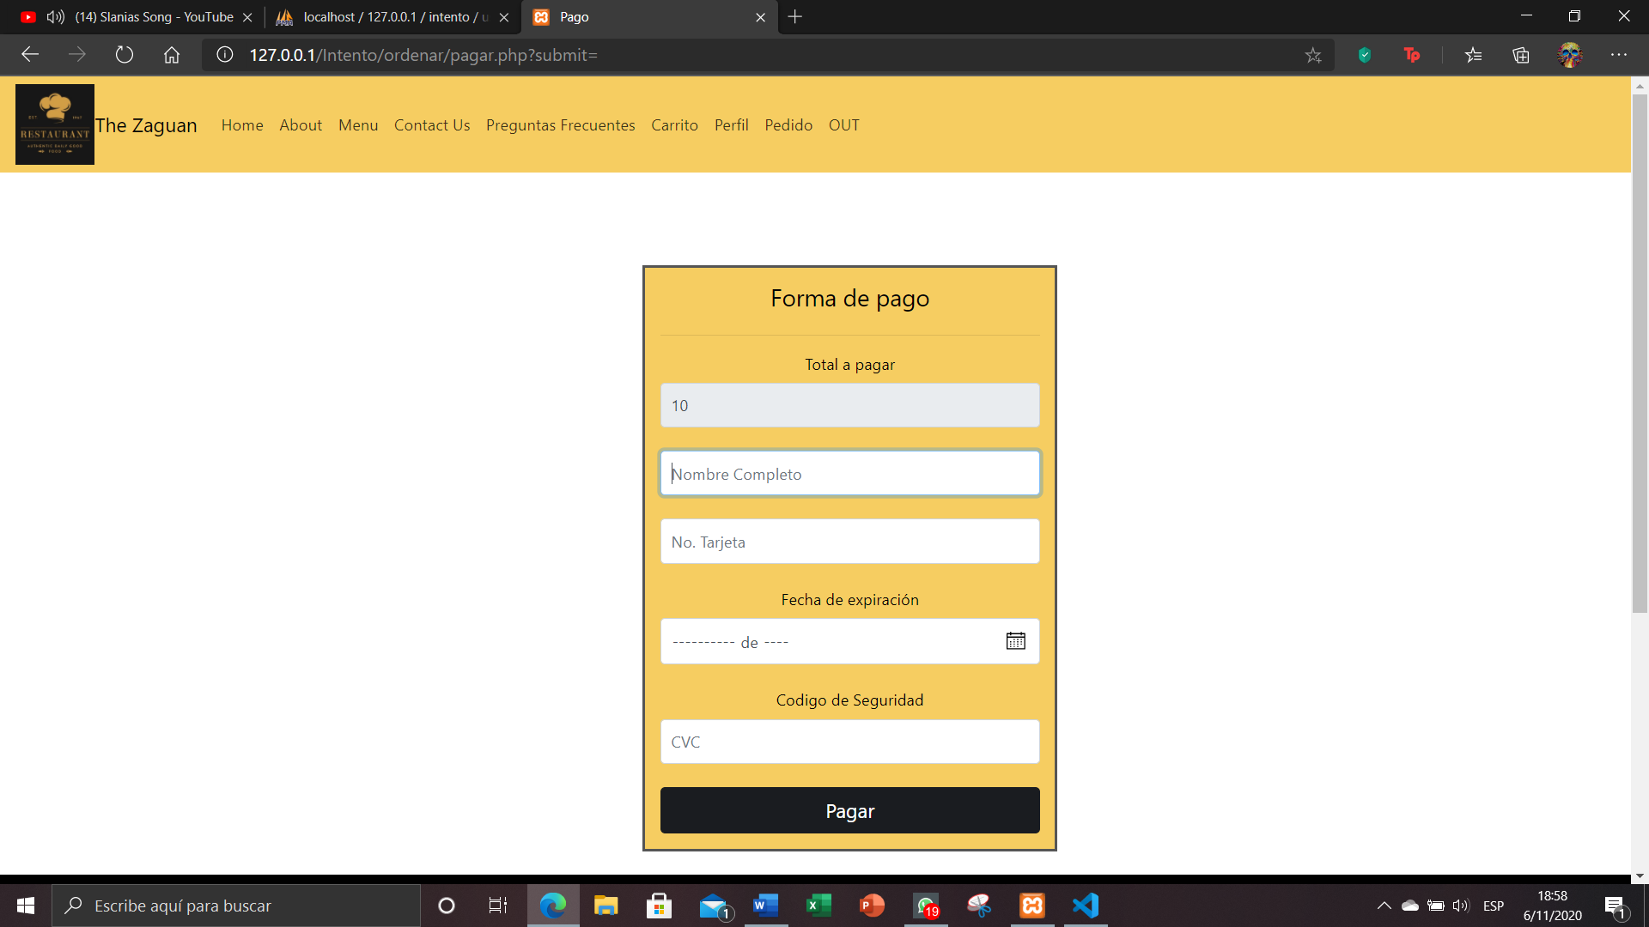

You can see the order that one has placed and see the status of the order. And to be able to make a comment on our order when it is already delivered.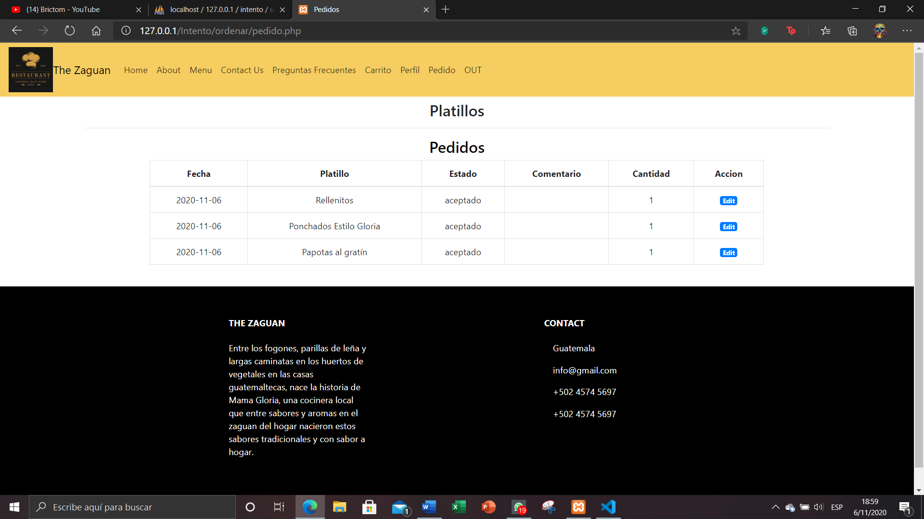

Here you can make a comment for each of the orders that have been made.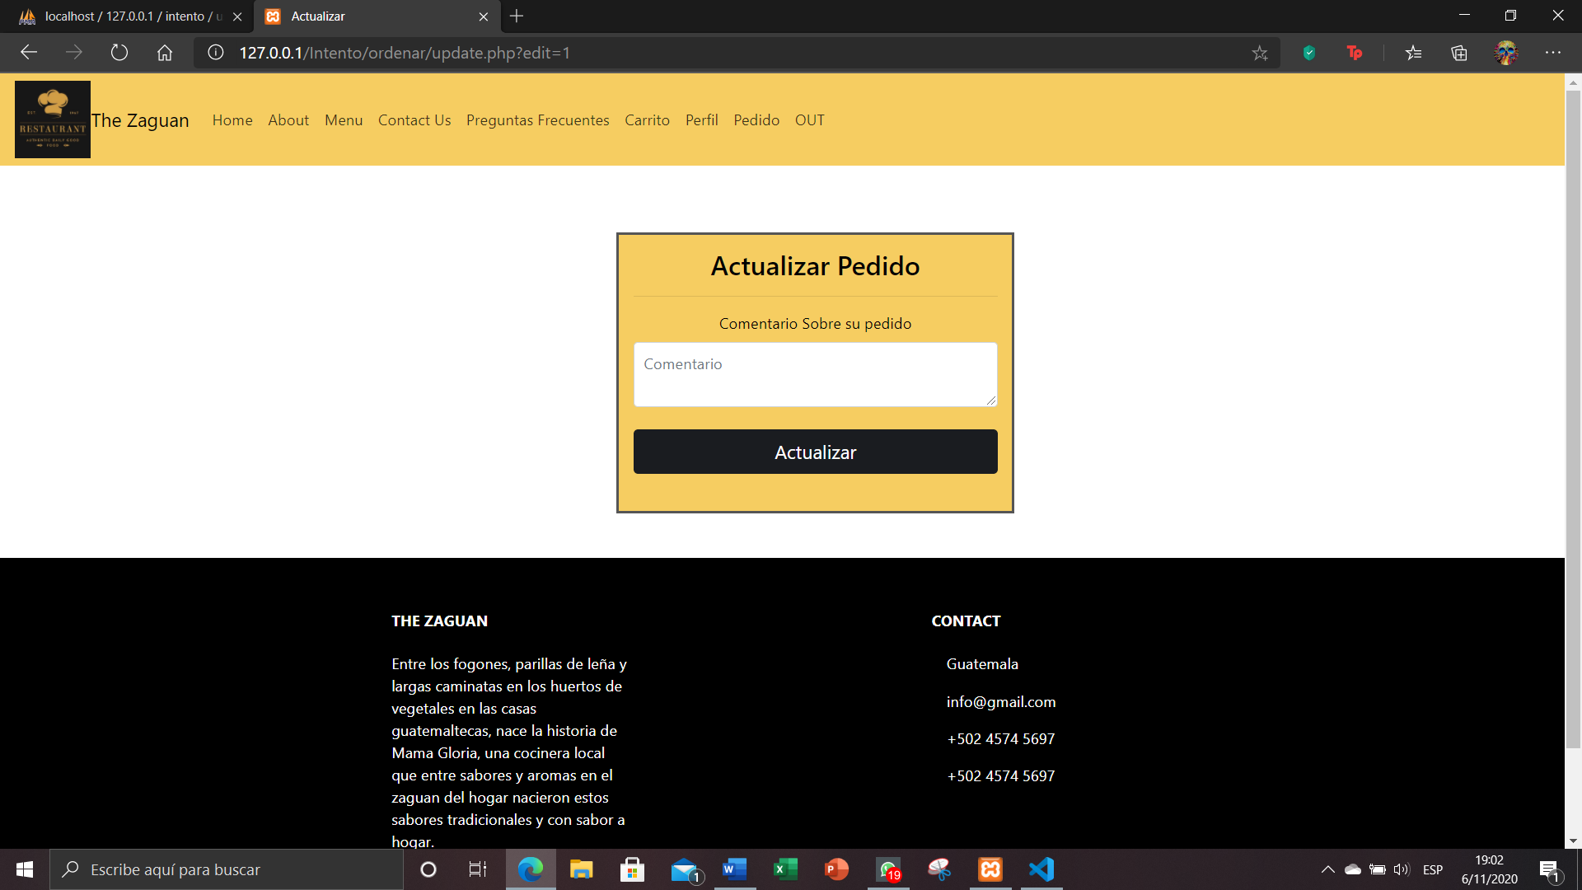

When a person is logged in, they will be able to see their profile with the information they entered when registering and they will be able to click to change the password.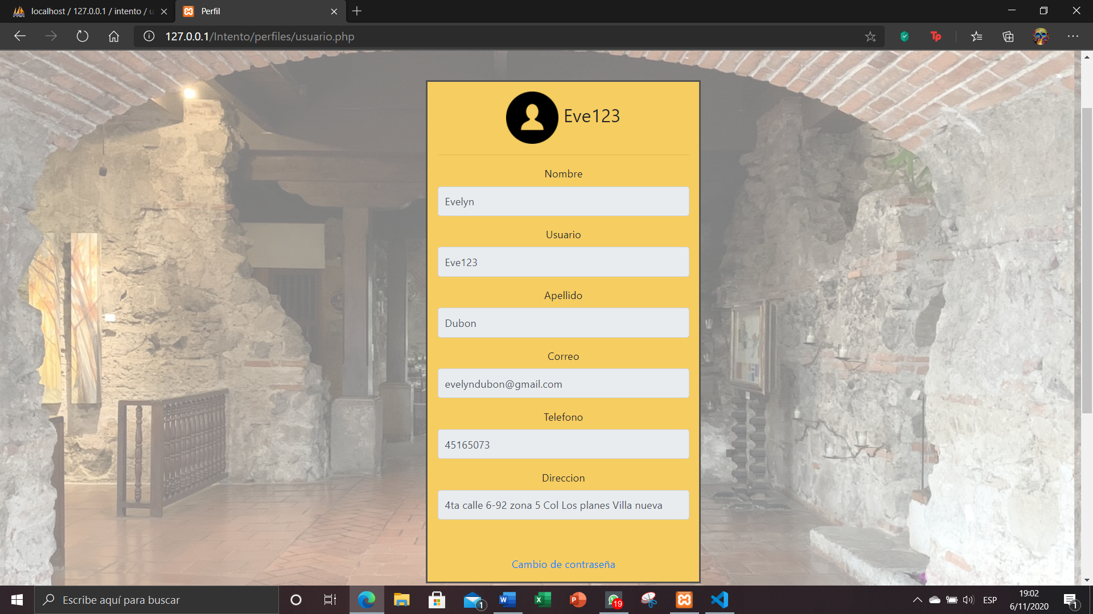

To change the password, you only have to enter a new password and it will be changed automatically.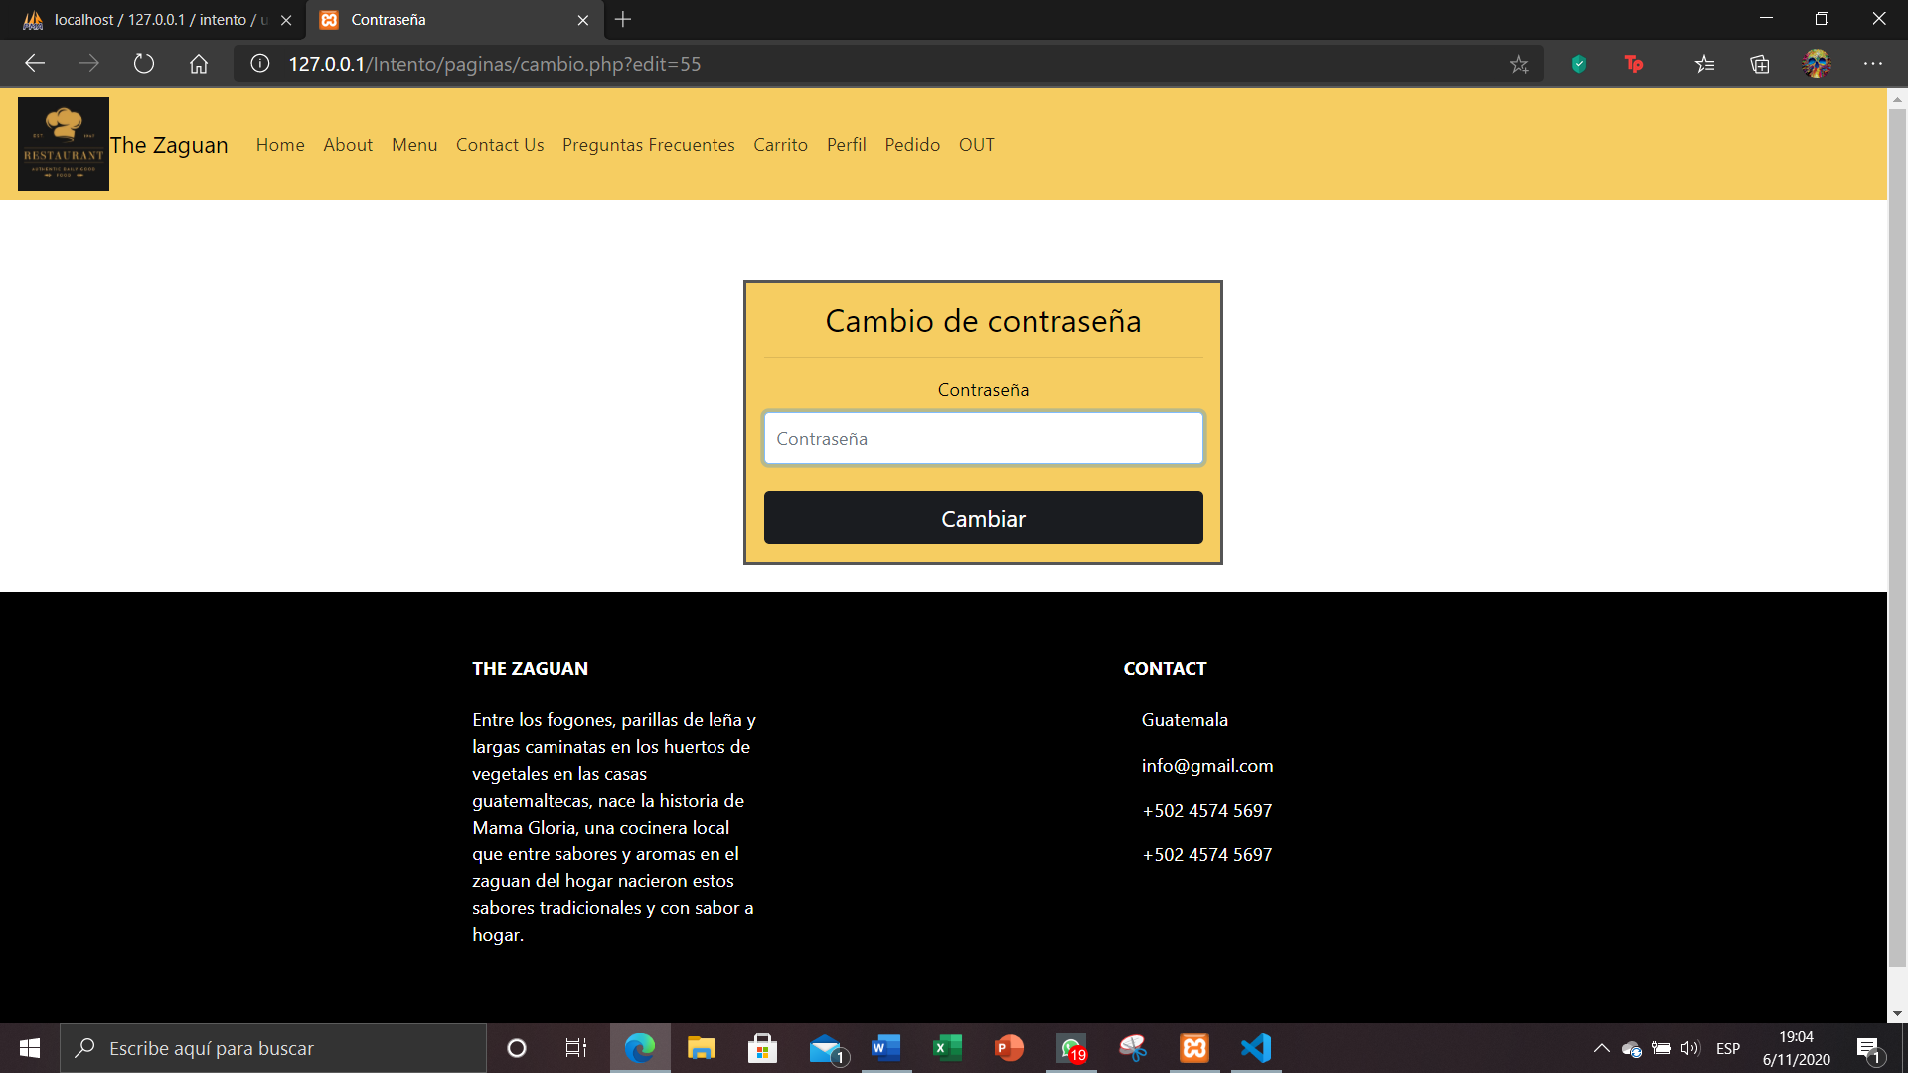

You can contact one of the people for any reason about what you want to know about our restaurant or dishes that are important.

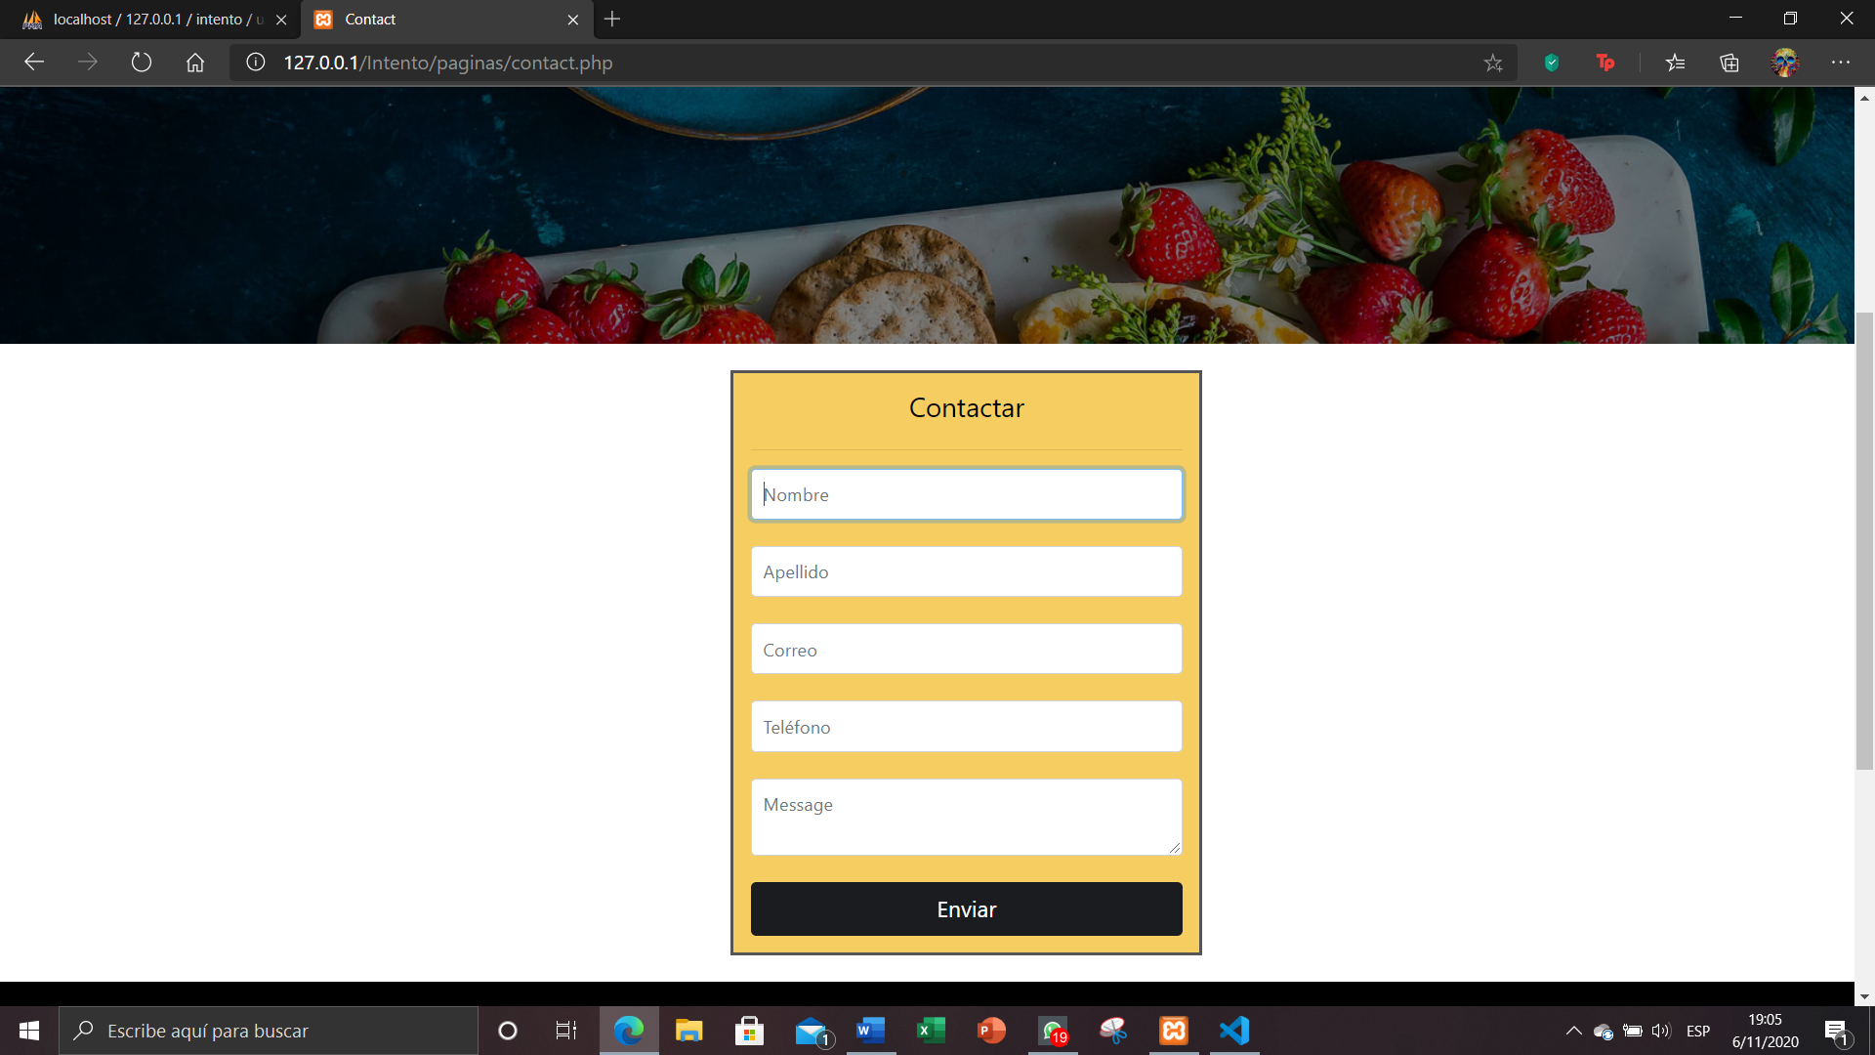

You will be able to observe the questions of something that cannot be done as such in order to solve the doubts that occur.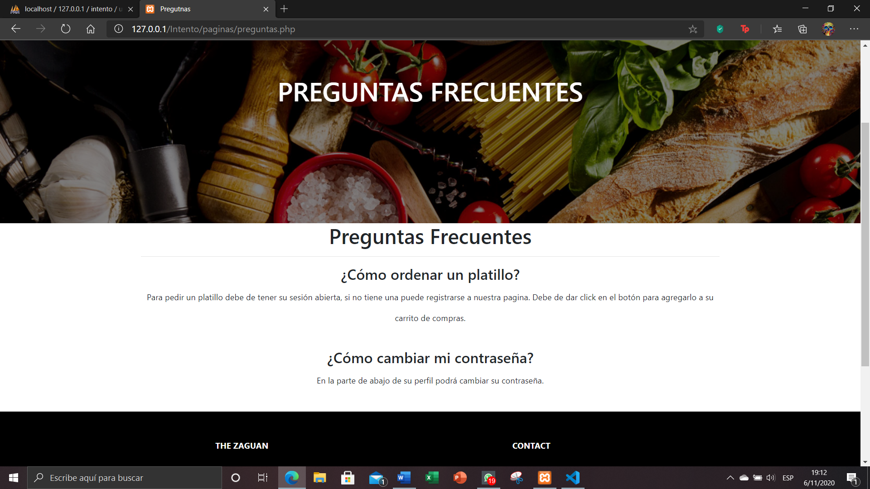

Para que uno pueda llegar a ingresar a su cuenta debe de escribir su usuario, y sino existe el usuario no podrá permitir el acceso sino que tendrá que ir a registrarse para poder crear una cuenta.

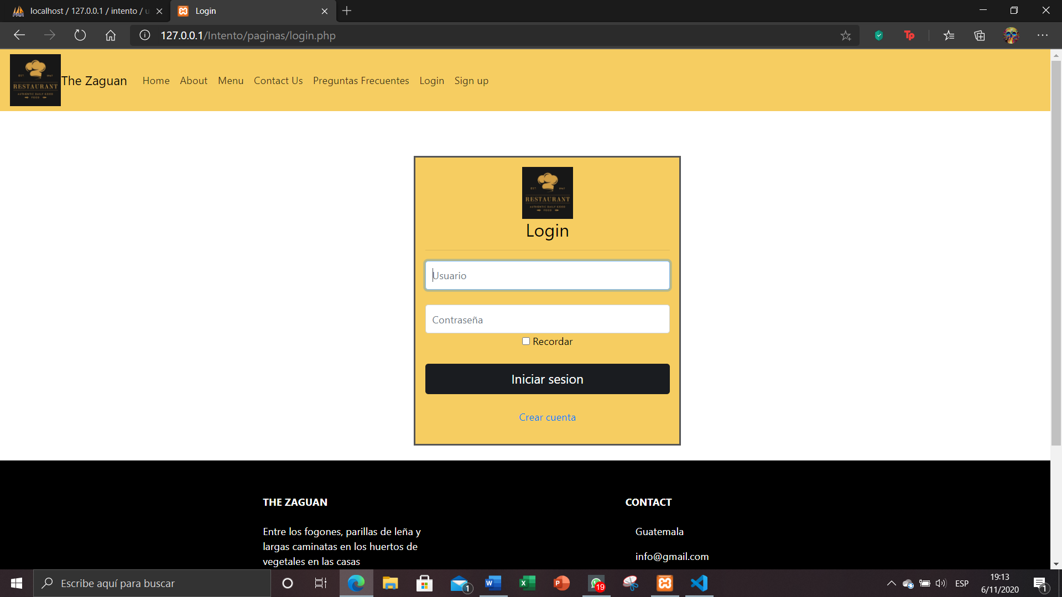

In order for one to be able to access their account, they must write their username, and if there is no user, they will not be able to allow access but will have to go to register to create an account.

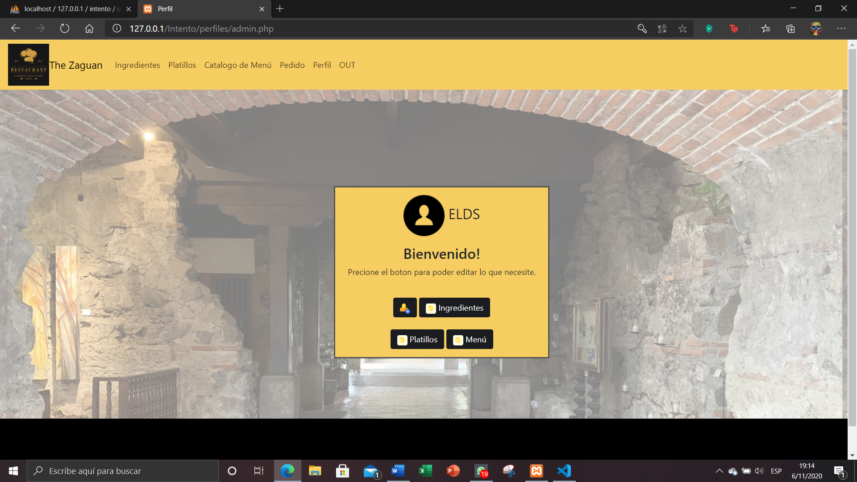

In the ingredients page you can search for each of the ingredients, you can enter a new ingredient and see that the entry has been made.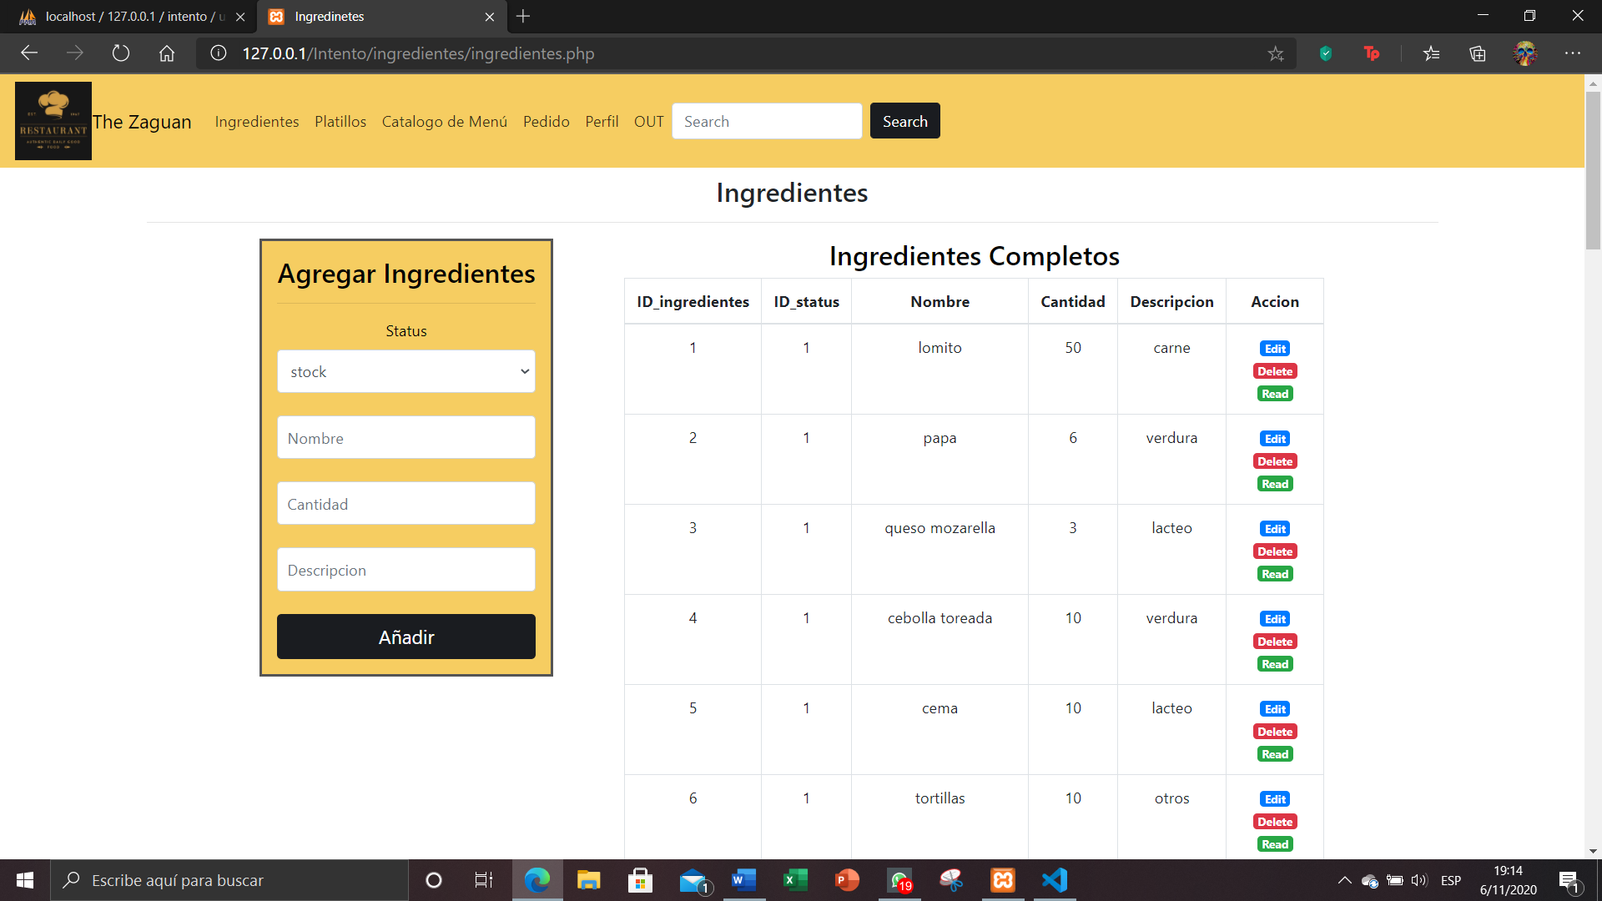

To update an ingredient, click on the edit button and you can change the status that it will have and the number of products that it will have.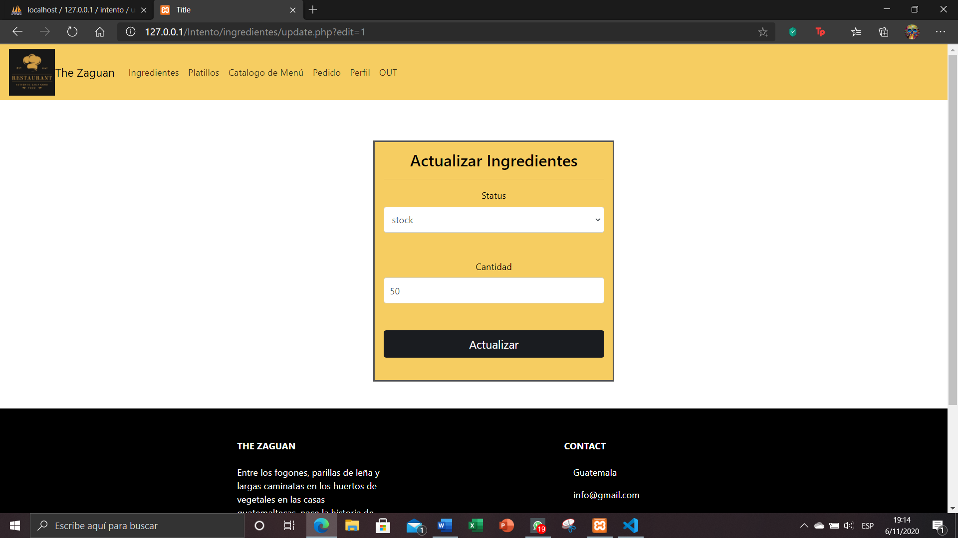

In order to read how the ingredient is, you can use the read button to see the information of each ingredient.

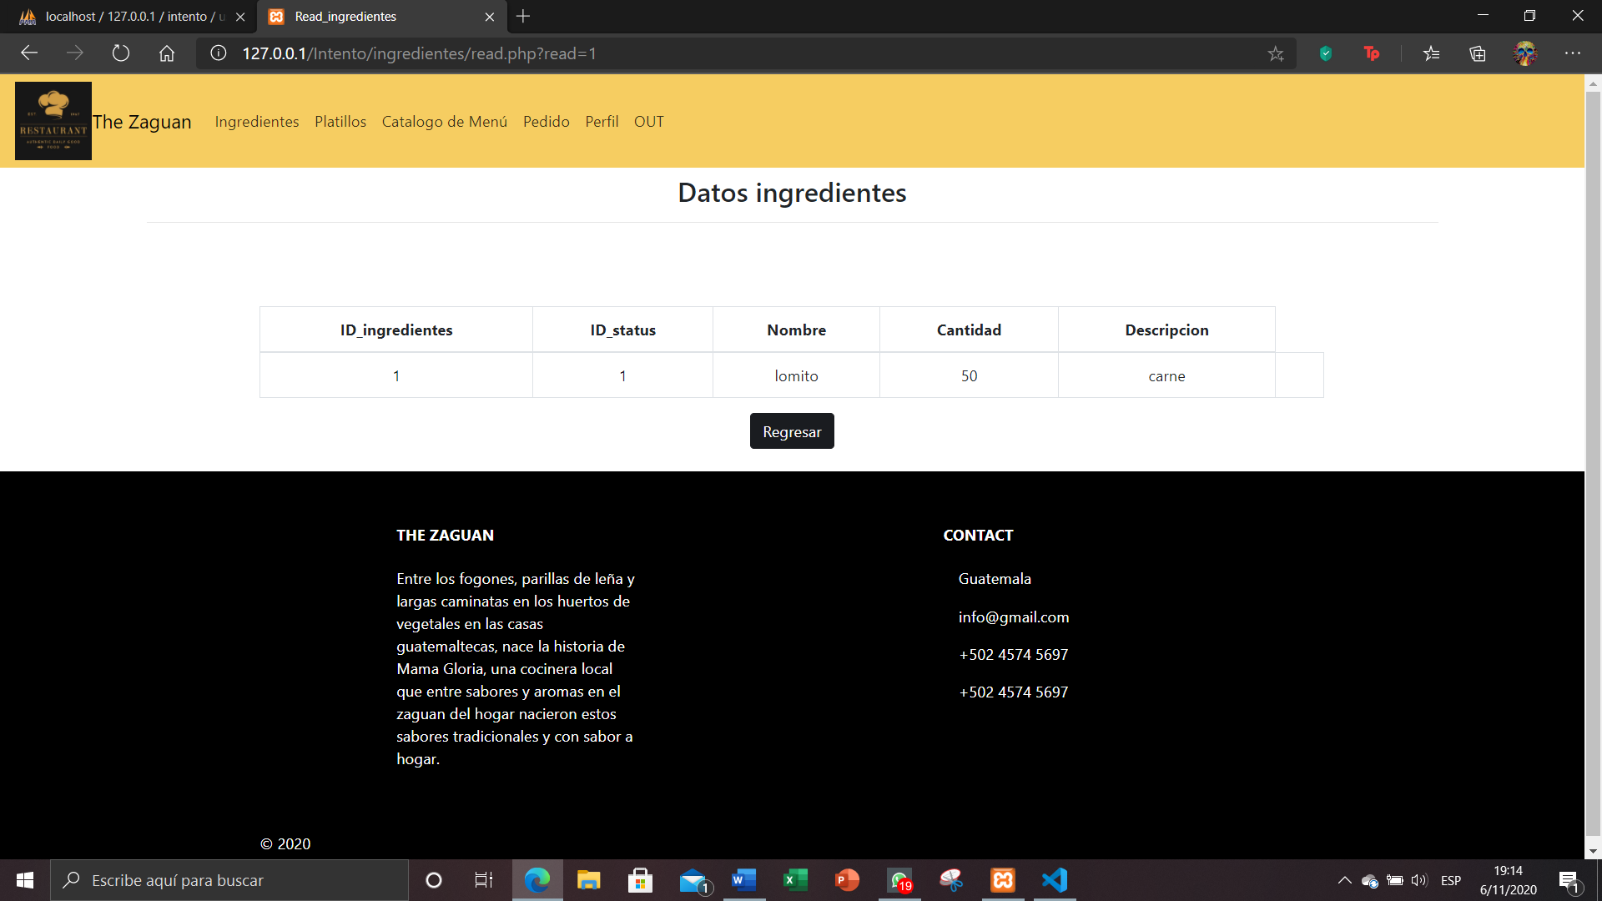

It is the same as that of ingredients with the dish, only in this case an image will be entered for each of the dishes.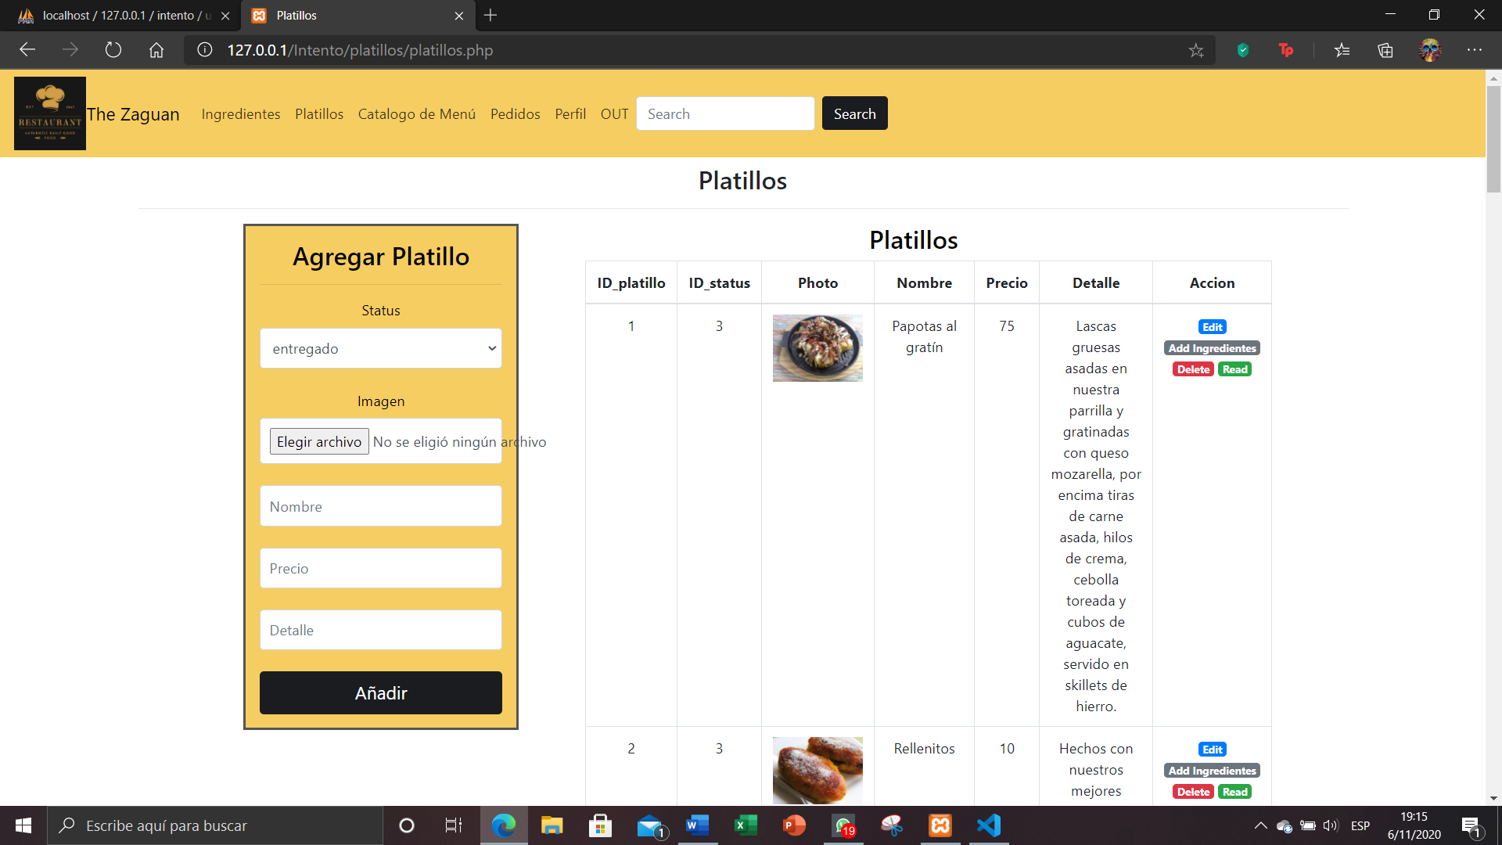

You can read the ingredients contained in each of the dishes and all the information about it.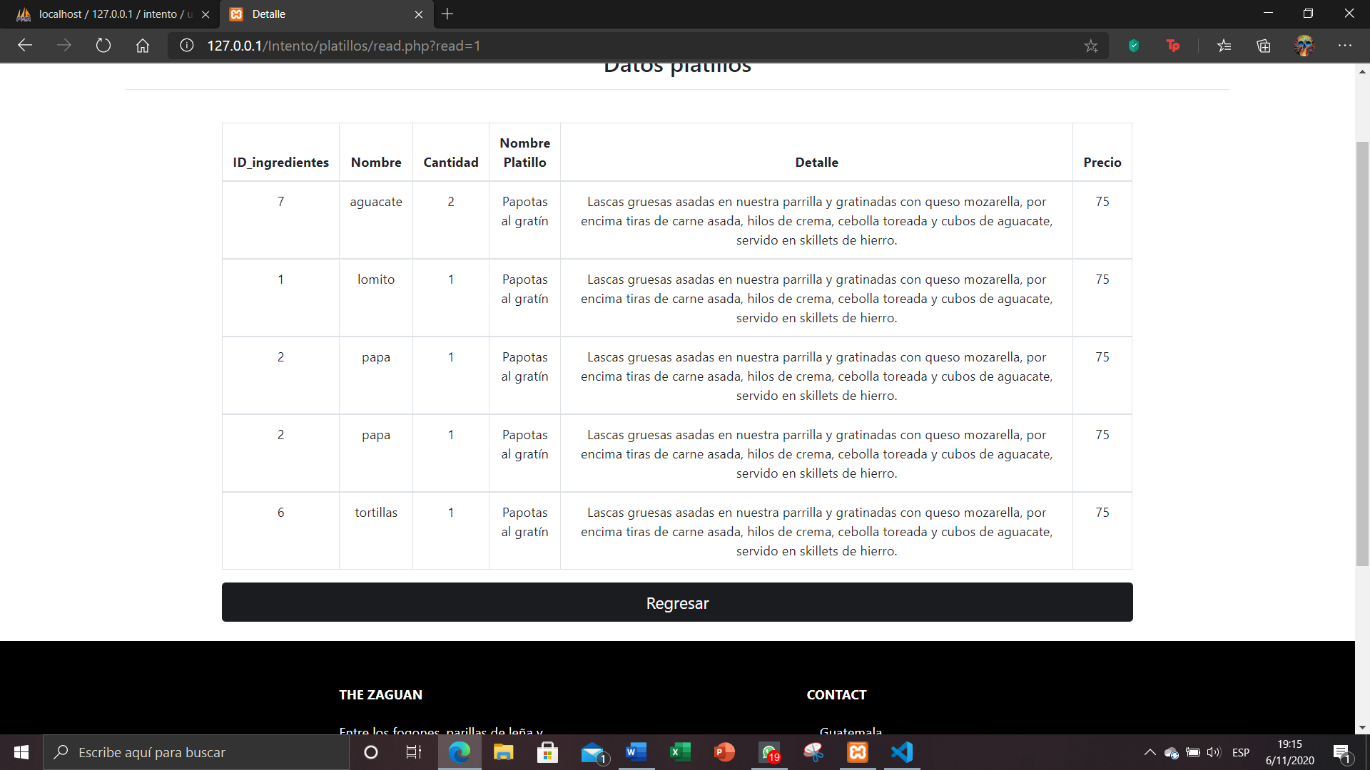

To add them to the menu is the same process as the previous ones, only because the type of food that will be put on this dish is entered.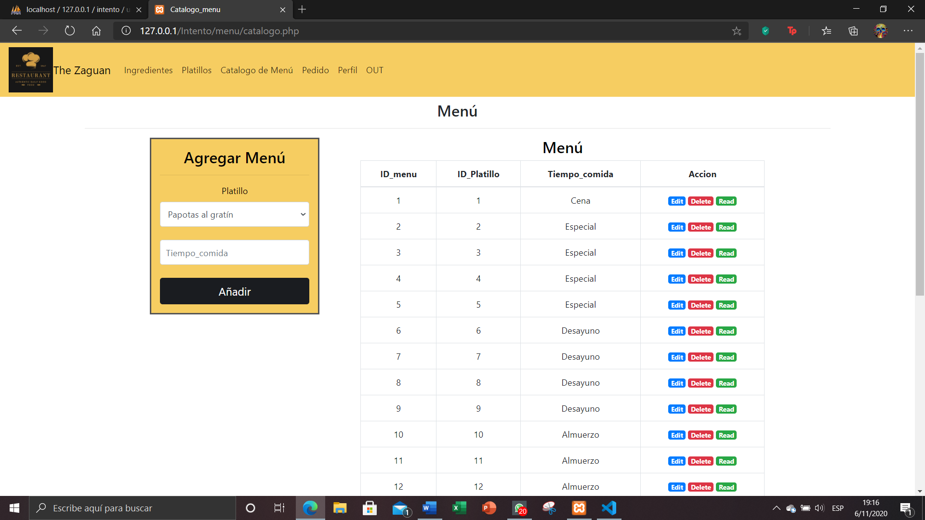

To be able to observe each of the orders that have been made by our clients, it will be possible to see what state it is in and we can edit it.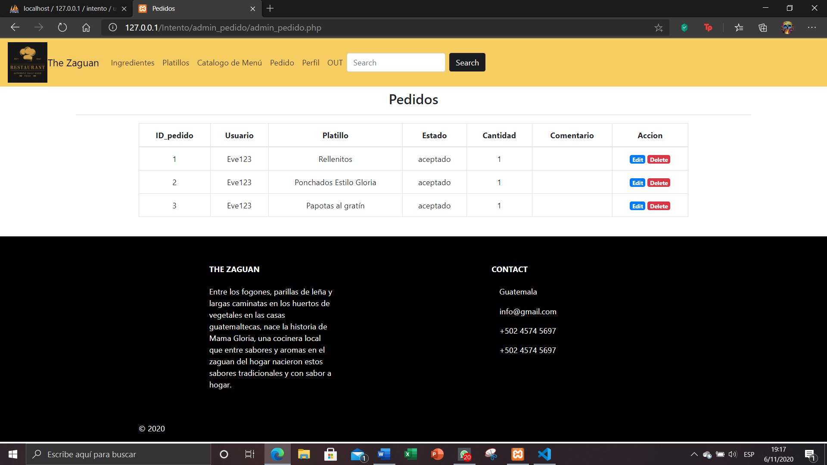

When editing them, you can edit both the status that will be when the order is processed and be able to make a comment on how the order is going.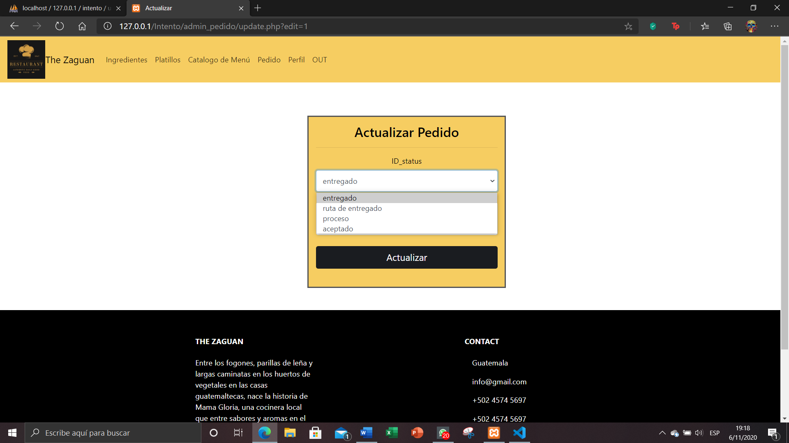

To register a new administrator and employee user, it will only be managed by the administrator putting the corresponding fields and his permission.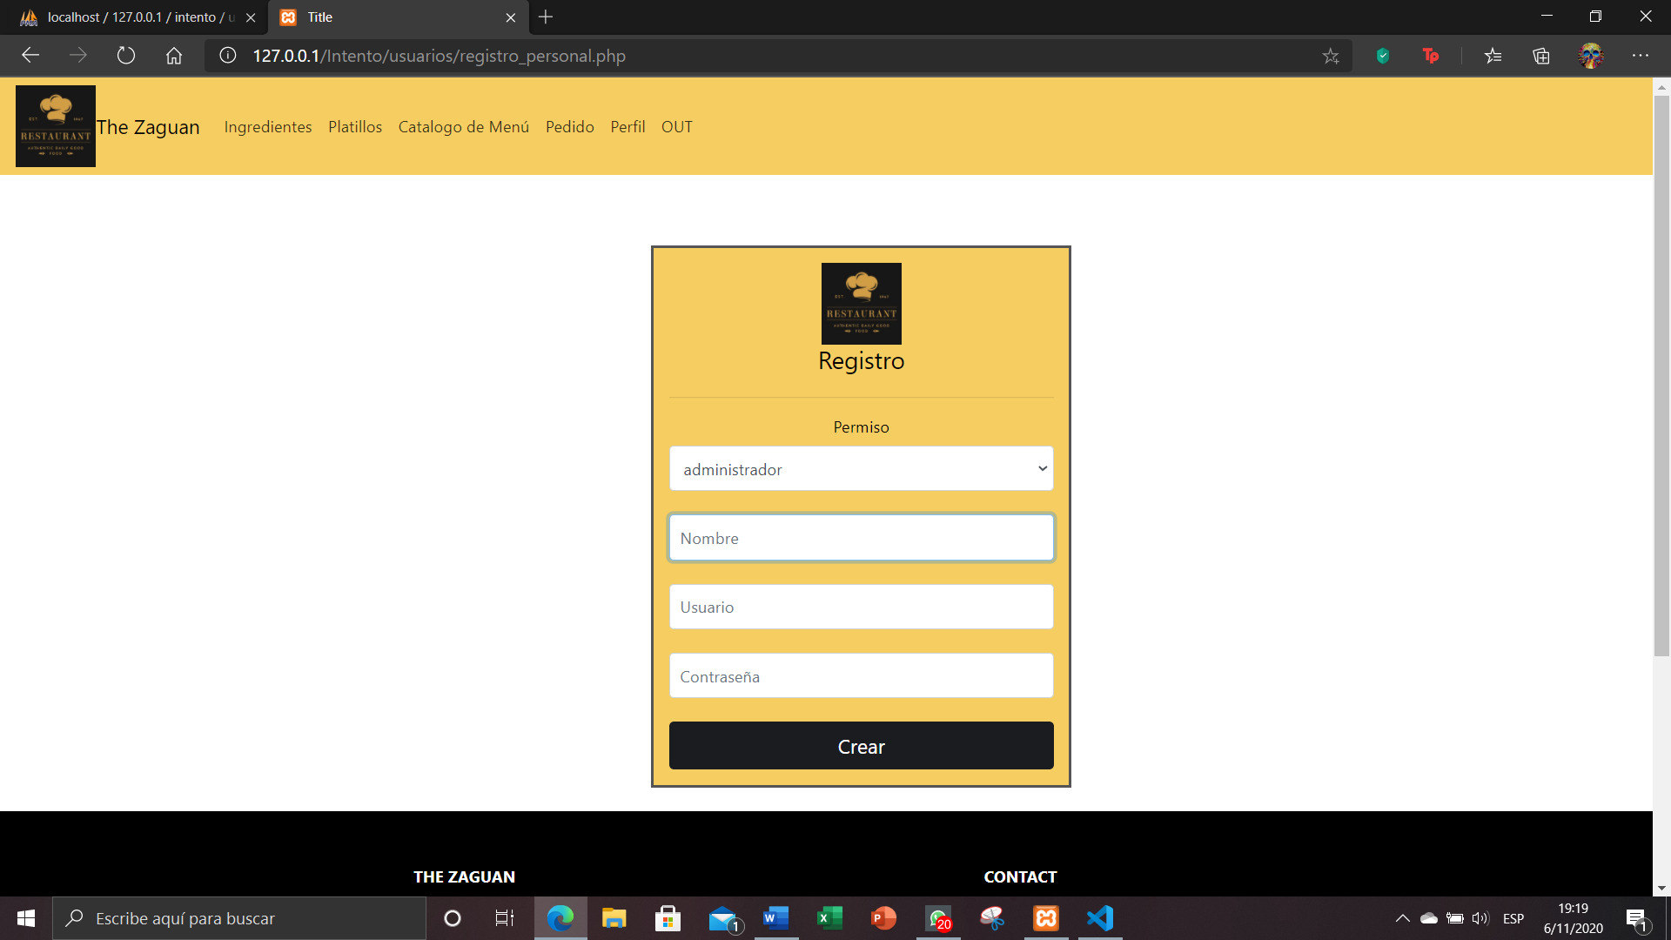

You can see all the existing users on our page and you can edit the role of each of the users you want.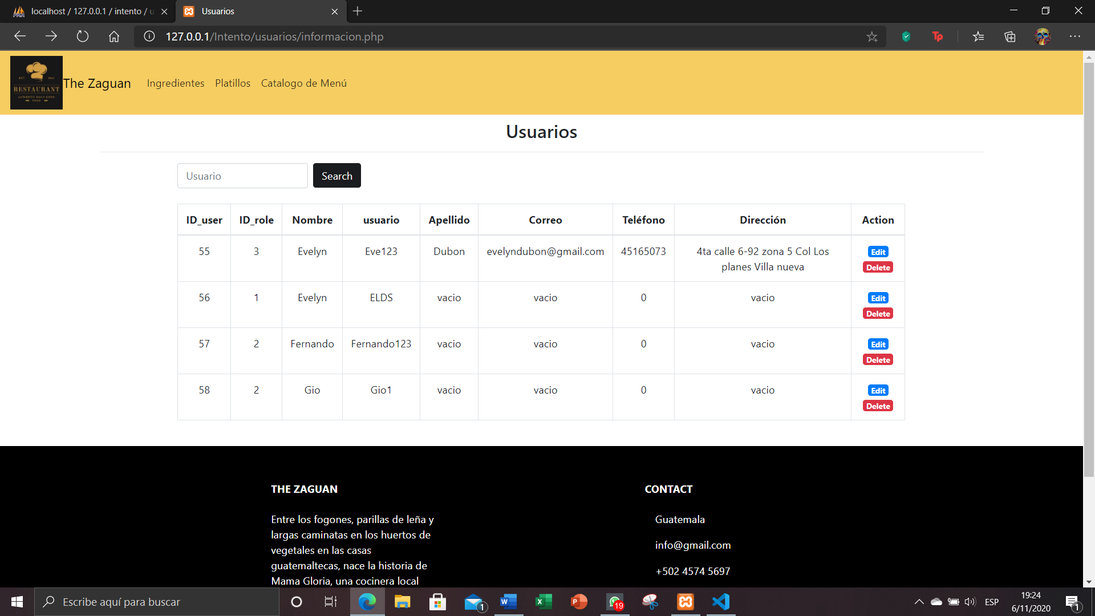

The user profile of an employee will only be able to have access to the ingredients, dishes, menu and orders to be able to make a change, verify or eliminate some things that they need.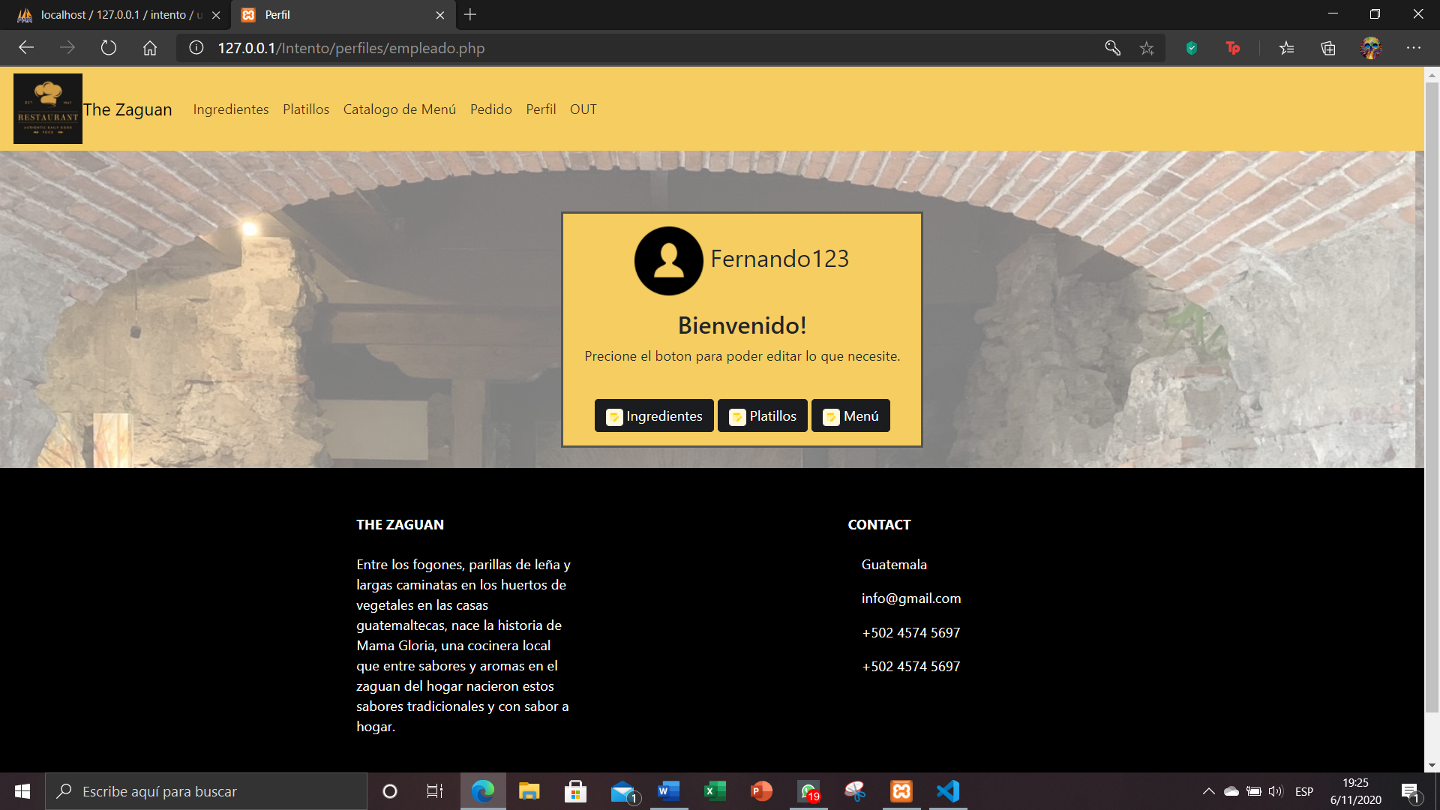

Registering for a new person in our restaurant when creating a new account.